

Quick order module

Functional Design Document

Document History

|  |  |  |  |
| --- | --- | --- | --- |
| **Version** | **Updated by** | **Date** | **Comments** |
| V1.0 | Hamzi BOUDIAF | 12/05/2015 | Creation |
| V2.0 | Sisi WANG | 22/05/2015 | Modificaiton |
|  |  |  |  |
|  |  |  |  |
|  |  |  |  |
|  |  |  |  |
|  |  |  |  |

Document Sign-off

|  |  |  |  |
| --- | --- | --- | --- |
| **Name** | **Role** | **Date** | **Signature** |
| **Pascal ESPINOUSE** |  |  |  |
| **Florent ESTUPINA** | **Hybris developer** | **19/05/15** | **Validation** |
|  |  |  |  |
|  |  |  |  |
|  |  |  |  |
|  |  |  |  |
|  |  |  |  |

Document references

|  |  |  |  |
| --- | --- | --- | --- |
| **Reference and Document Title** | | **Version Number** | **Date** |
|  | CGHA_Quick_order_FDD_V1.0.docx | V1.0 | 12/05/2015 |
|  | CGHA_Quick_order_FDD_V2.0.docx | V2.0 | 22/05/2015 |

# Table of Contents

Table of Contents 2

1 Introduction 3

1.1 Aim of this document 3

1.2 Reading the specifications 3

2 Quick order module description 4

2.1 Benefits 4

2.2 Description 4

2.3 Use cases 4

2.3.1 Create a quick order 4

2.3.2 Create a quick order from CSV 4

2.4 Functional details 4

2.4.1 Create a quick order 4

2.4.2 Create a quick order from CSV 6

# Introduction

## Aim of this document

The aim of this document is to provide the Functional Requirement Specifications (FRS) corresponding to the functional description of requirements of the module Quick order.

## Reading the specifications

Each functionality is described as follows:

**Alert messages**

* Alert messages post fixed with (*) are given as information. They will be updated globally during the project.

**As a customer, I want to etc.**

* Story description for each functionality.

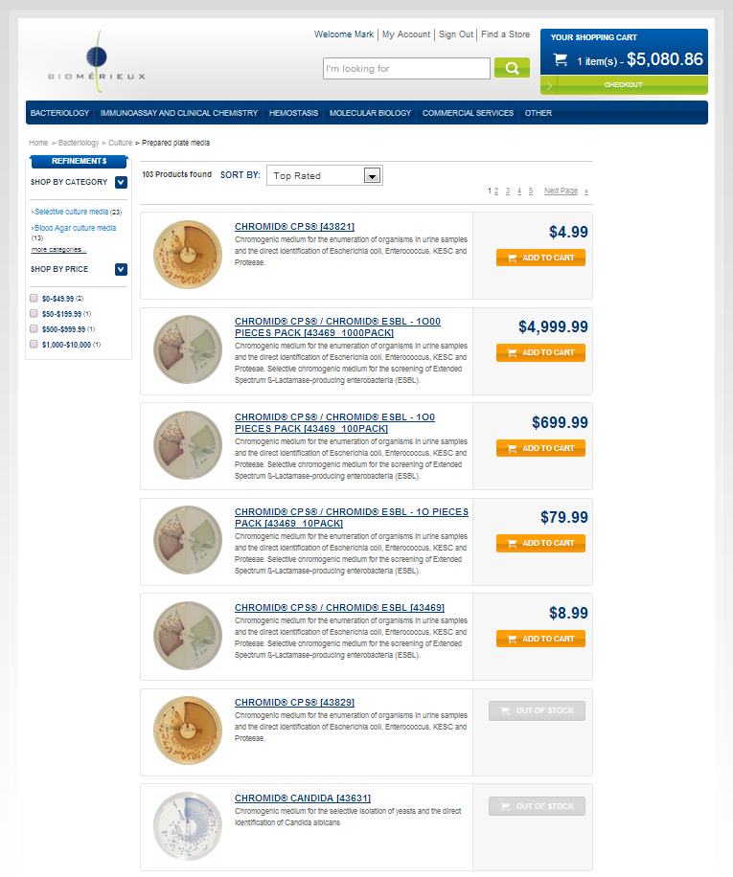

➊

➋

* The screen shot is used to illustrate the functionality.

###### Description - specific

|  |  |
| --- | --- |
| **Name** | **Description** |
|  |  |

* Detailed description for the specific development

# Quick order module description

## Benefits

In a B2B site, the users are usually professional buyers. The more the site makes their job easier the more they will come back and purchase more products.

The quick order helps to fulfill this point by providing a fast and reliable order process: filling in only two fields “SKU number” and “Quantity”.

## Description

A B2B buyer often knows exactly what they need to purchase (the SKU numbers of the products).

The quick order module enables the buyer to create a shopping cart by simply fill in the SKU numbers and quantity he need to purchase. He does not have to navigate through the product catalog. This module uses the auto-completion for the product SKU number.

This module also enables the buyers to upload a CSV file containing the SKU number and quantity. A template the CSV file can be downloaded from quick order module.

## Use cases

### Place a quick order

As a customer, I want to quickly place an order.

### Place a quick order from CSV

As a customer, I want to quickly place an order by uploading a CSV file.

## Functional details

### Create a quick order

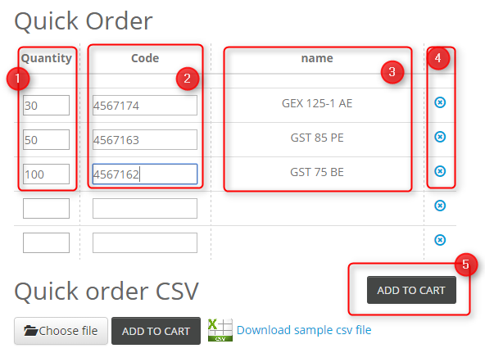

Illustration: Quick order webpage

###### Description - specific

|  |  |
| --- | --- |
| **Name** | **Description** |
| **Description** | This section describes the quick order.  For this version, there is no control rules implemented on the controller.  If the current cart is not empty, a warning message is displayed. |
| **1 – Quantity** | The user enters the quantity of the products in the text field. He can also use the arrow up and down to define the quantity. |
| **2 – Code** | The user enters the SKU number of the product in the text field.  The auto-completion is triggered when there are at least 3 characters filled in the field (the number of characters needed to trigger the auto-completion can be configured in the back-office). |
| **3 – Name** | The name of the product is displayed in the name section once a SKU number is entered. |
| **4 – Delete** | When clicking on the cross, the product line corresponding is deleted (quantity, code and name). |
| **5 – “Add to cart” button** | When clicking on the “add to cart” button, the user will be redirected to the cart page which will show the detailed cart information.  This action uses the same verification rules as the standard hybris add to cart functionality (check stock, etc…)  At the same time, the mini cart is automatically updated with number of items in total and the total amount of the cart.  D:\Users\hboudiaf\Documents\Hybris\B2B Asset\Specifications\quickorder-minicart.png  The user can continue his shopping or checkout. |

### Create a quick order from CSV

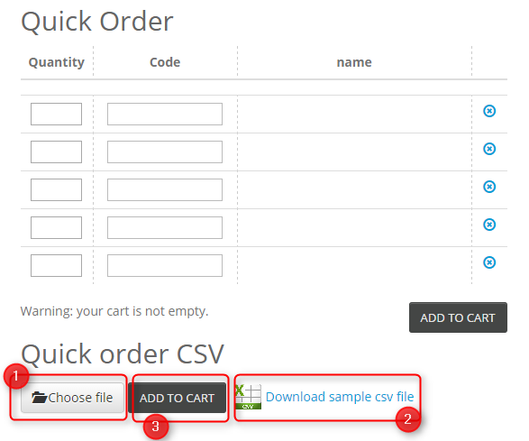

Illustration: Quick order webpage

###### Description - Specific

|  |  |
| --- | --- |
| Name | Description |
| Description | This section describes the uploading CSV functionality of the quick order module. |
| 0 - CSV file format | The CSV file is composed of two columns :   * SKU number * Quantity   D:\Users\hboudiaf\Documents\Hybris\B2B Asset\Specifications\quickorder-csv.png  The user can upload an existing file (1) or create a new one from a template (2) |
| 1 – Choose file | The user can find the file to upload with the windows explorer |
| 2 – Sample file | The user can download a template of the CSV file with the right format by clicking on the link. |
| 3 – add to cart button | When clicking on the “add to cart” button, the user will be redirected to the cart page which will show the detailed cart information.  This action uses the same verification rules as the standard hybris add to cart functionality (check stock, etc…)  At the same time, the mini cart is automatically updated with number of items in total and the total amount of the cart.  D:\Users\hboudiaf\Documents\Hybris\B2B Asset\Specifications\quickorder-minicart.png  The user can continue his shopping or checkout. |